###### Experiment Number: 02 OS

**Name : Jay Pawar Roll No : 22**

**Div : TY-CS-B Batch : B1**

1. **Arithmetic Operations**

**Code:**

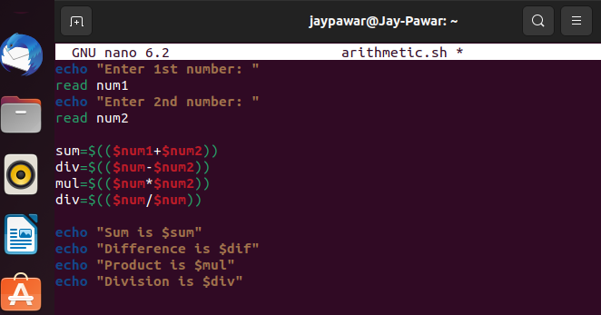

**Output:**

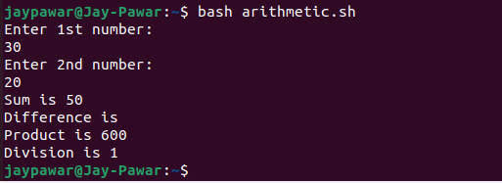

1. **Control Structures**
2. **if…else...**

**Code:**

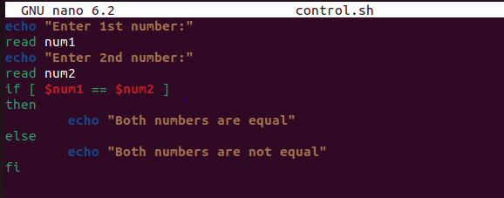

**Output:**

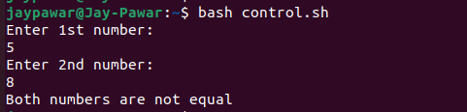

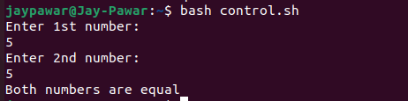

1. **Switch Case**

**Code:**

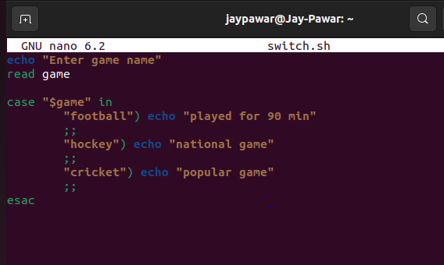

**Output:**

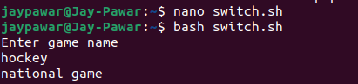

1. **Loops**
2. **for loop**

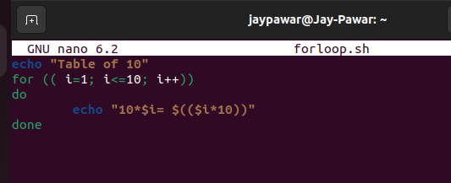

**Code:**

**Output:**

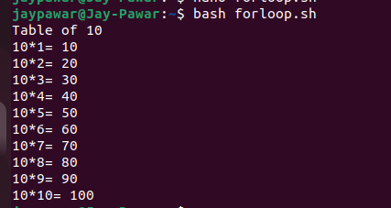

1. **while loop**

**Code:**

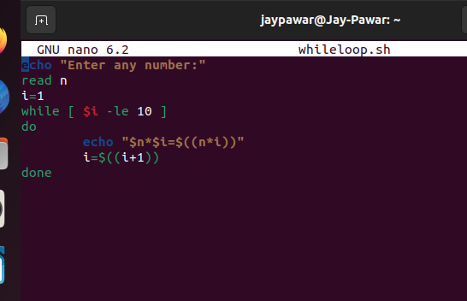

**Output:**

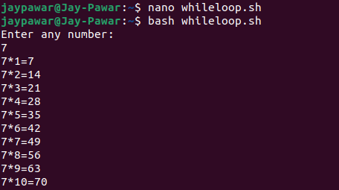

1. **Command Line Argument**

**Code:**

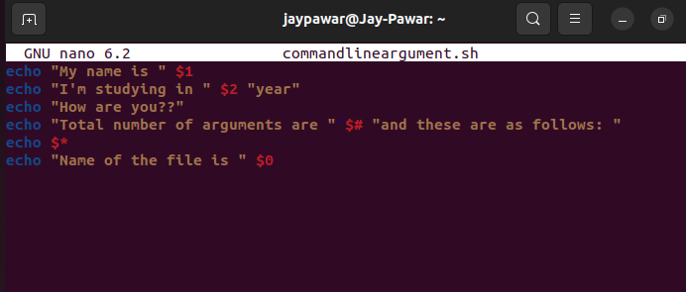

**Output:**

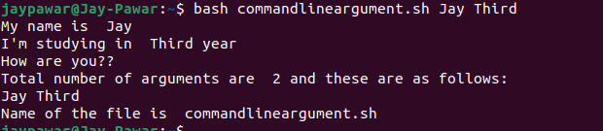

1. **Functions**

**Code:**

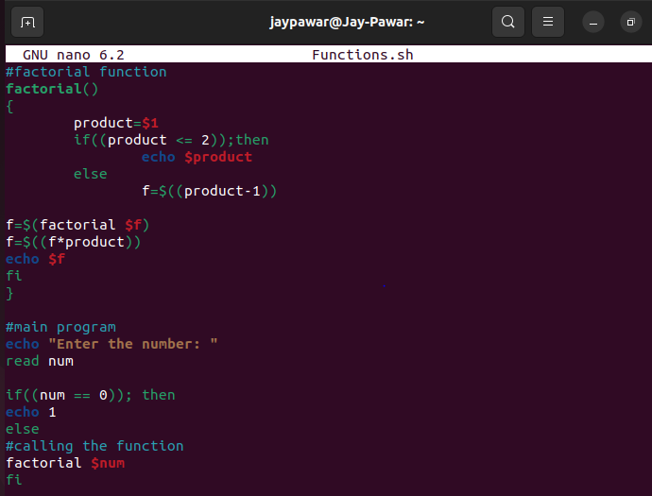

**Output:**

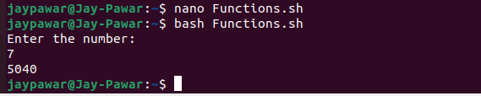

1. **Arrays**

**Code:**

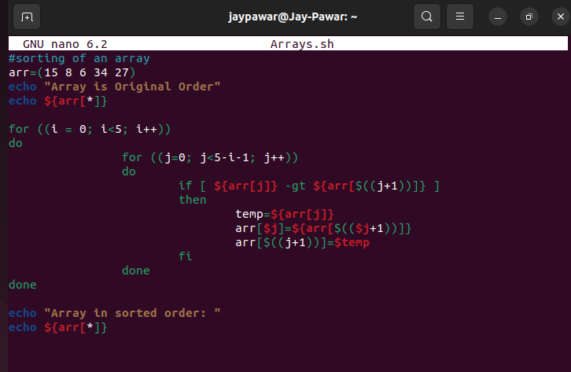

**Output:**

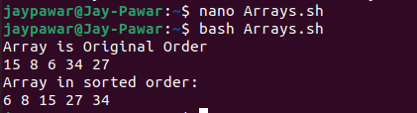

1. **String Operation**
2. **Length of the string**

**Code:**

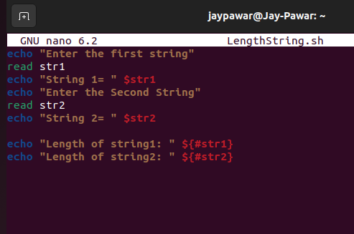

**Output:**

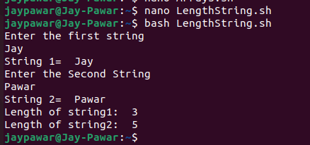

1. **Reversing a string**

**Code:**

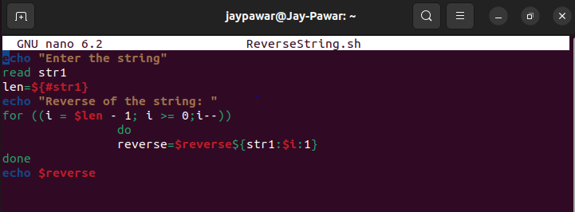

**Output:**

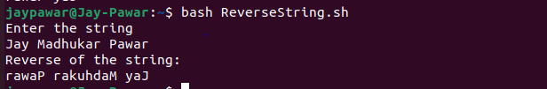

1. **Checking a string is palindrome or not**

**Code:**

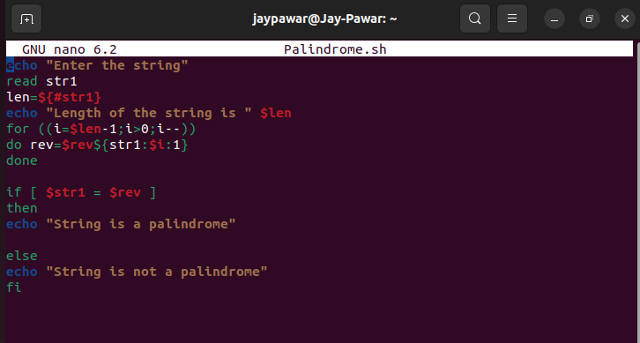

**Output:**

